1) Which kernel version we are using for rugged board, write the command for kernel compilation ?
Ans:- The kernel version for a rugged board can vary depending on the specific board and its configuration. To find the kernel version, you can use the following command

uname -r
For kernel compilation in Linux porting, you can use the following commands:
make menuconfig
make
2) What do you understand by device tree node?
Ans :- A Device Tree Node is a data structure that describes hardware components and their configurations in a system for Linux Embedded Porting.

3) Write all the functions of device tree.?
Ans:- In Linux Embedded Porting, the Device Tree serves the following functions:
- Hardware Description: Describes the hardware components in a system.
- Configuration Information: Provides configuration details for kernel drivers and platform-specific settings.
- Dynamic Device Enumeration: Enables the kernel to dynamically recognize and configure devices at runtime.
- Platform Independence: Facilitates portability by separating hardware details from the kernel code.
- Versioning: Allows for evolution and adaptation of hardware without modifying the kernel source code.

4) What is the purpose of kconfig file. ?
Ans :- The purpose of a Kconfig file in Linux Embedded Porting is to configure kernel build options and select features during the compilation process

5) Write a command to insert any kernel object file.?
Ans:- insmod <module_name>.ko

PART B

1) Why we required device tree for kernel compilation, and also mention the location of rugged board dts files
Ans:- We require the Device Tree for kernel compilation to provide hardware description and configuration information, allowing for platform-independent kernel builds. Rugged board DTS files are typically located in the /arch/arm/boot/dts/ directory in Linux Embedded Porting.

2) Explain kernel architecture.

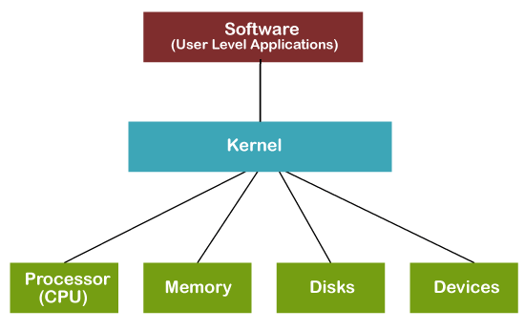
3) Write all the steps involved in compiling kernel image and driver. ko file. ?
Ans :- Configure Kernel:
  - Use make menuconfig to configure kernel options.
- Compile Kernel:
  - Execute make to build the kernel image (zImage or Image).
- Compile Modules:
  - Use make modules to compile kernel modules.
- Install Modules:
  - Run make modules_install to install compiled modules.
- Copy Kernel Image:
  - Copy the kernel image to the boot directory (e.g., /boot).
- Update Bootloader:
  - Update the bootloader configuration to recognize the new kernel.
- Reboot System:
  - Reboot the system to use the newly compiled kernel.
- Insert Kernel Module:
  - Use insmod to insert the compiled .ko driver file into the kernel.

4) Explain the kernel code fliow. ?
Ans :- Bootloader:
- The bootloader loads the Linux kernel into memory.
- Kernel Initialization:
- The kernel initializes critical data structures and sets up the initial environment.
- Start Scheduler:
- The scheduler selects the first process for execution.
- Process Execution:
- The selected process runs until an event occurs, such as an interrupt or system call.
- Interrupt Handling:
- When an interrupt occurs, the control transfers to the corresponding interrupt handler.
- Interrupt Service Routine (ISR):
- The ISR executes actions in response to the interrupt, which may involve servicing hardware or handling system calls.
- Process Switching:
- The scheduler may switch to a different process based on priority or time-slicing.
- Device Drivers:
- Device drivers facilitate communication between the kernel and hardware devices.
- File System:
- File system operations manage file access and storage.
- User Space:
- Control transfers to user-space for application execution

